Project Documentation: Student Admission Portal

1. Aim of the Project
To develop a Student Admission & Course Portal using Angular. This project demonstrates core concepts like Data Binding, Directives, and Custom Pipes to manage student records and enrollment status in a meaningful, real-world application.

2. Implementation Details (Code & Logic)
Below are the core files used in this project along with their code and placeholders for your code-editor screenshots.

A. Main Entry (app.ts)
This is the root component that hosts the Student Portal.

import { Component } from '@angular/core';
import { StudentComponent } from './student/student';

@Component({
selector: 'app-root',
standalone: true,
imports: [StudentComponent],
template: `<app-student></app-student>`
})
export class App {}

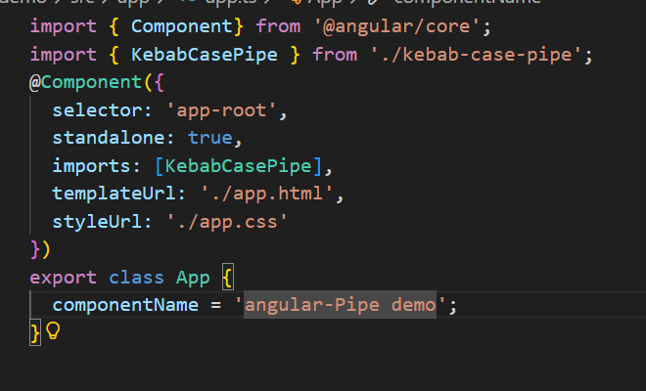

B. Portal Logic (student.ts)
Handles the admission form logic and student data array.
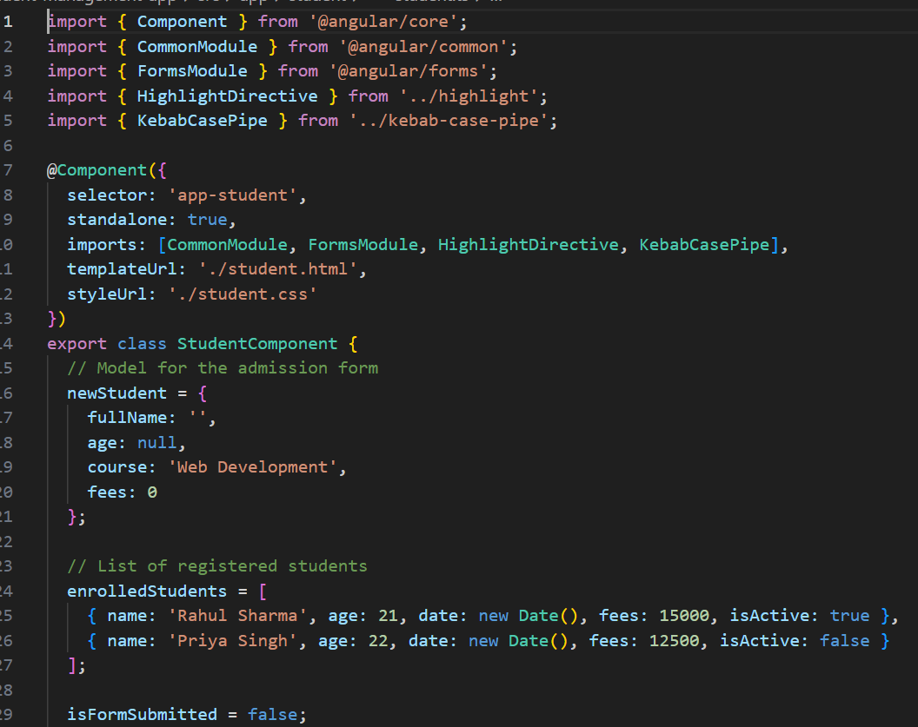
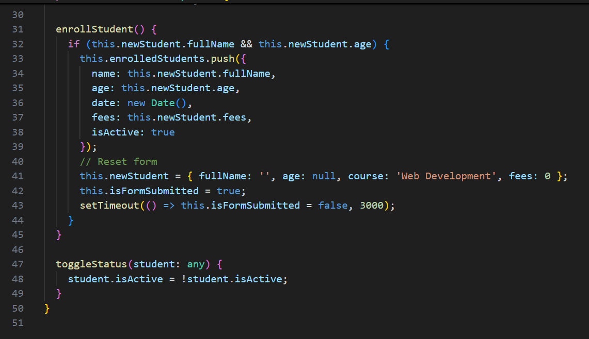

C. Portal Template (student.html)
The UI structure using ngModel, *ngFor, and *ngIf.
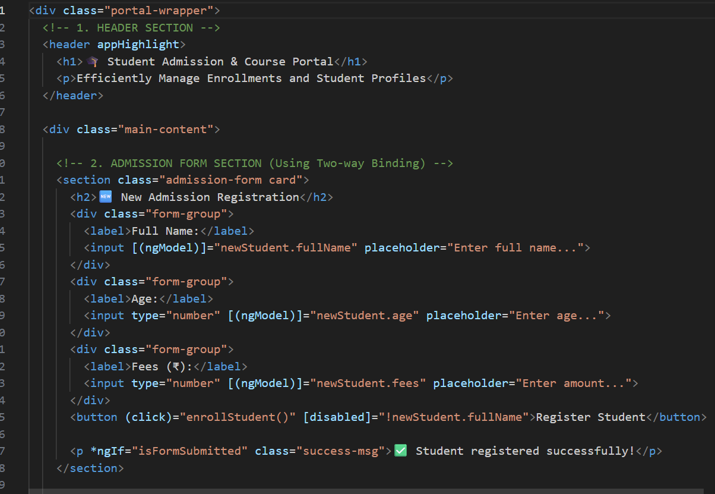
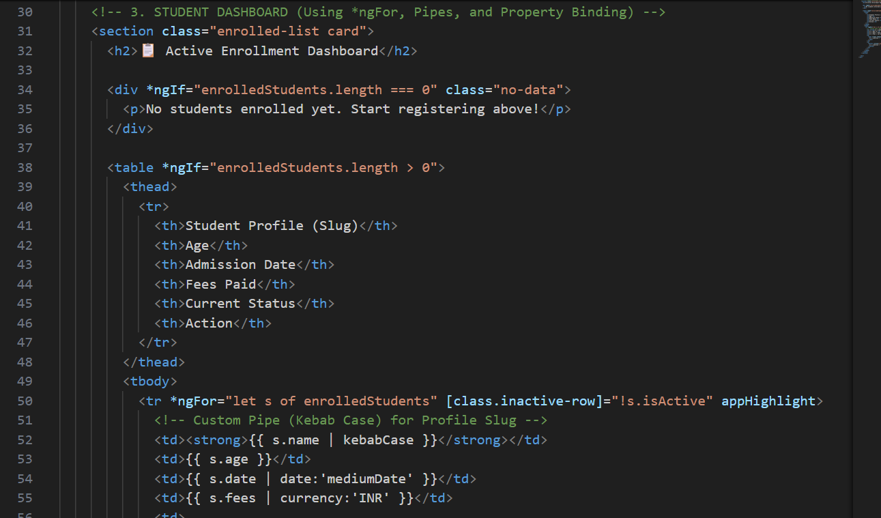
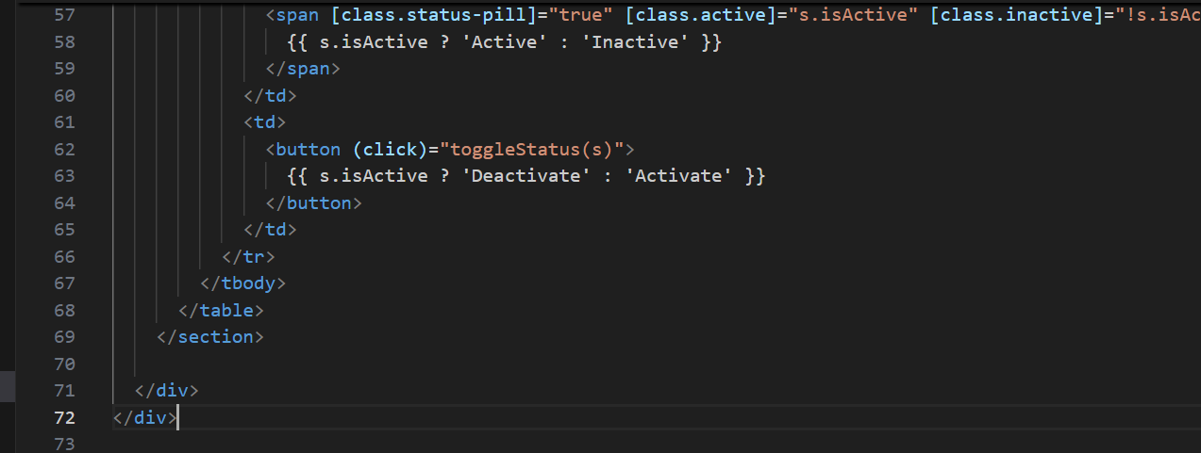

D. Custom Attribute Directive (highlight.ts)
Changes background color on hover using @HostListener.
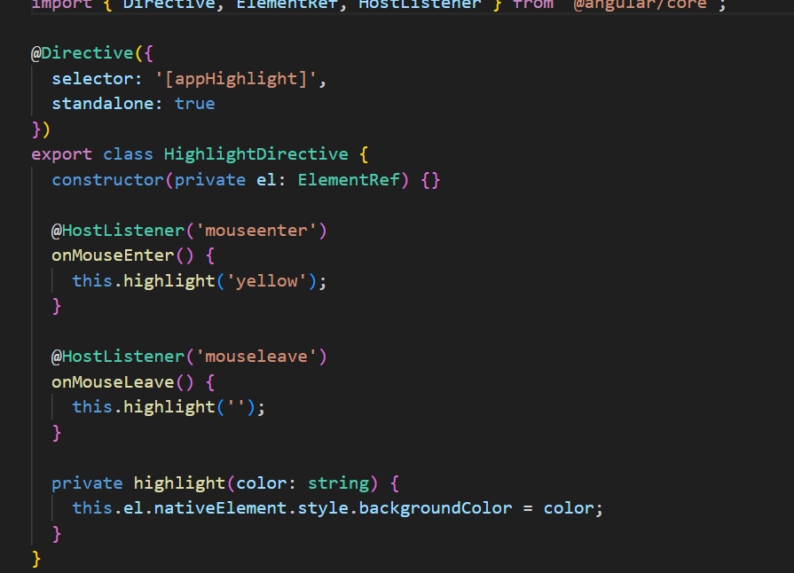

E. Custom Pipe (kebab-case-pipe.ts)
Transforms names into URL-friendly slugs.
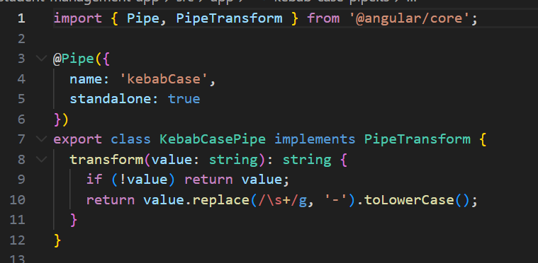

3. Final Project Output (Visuals)
Once the code is implemented, here is how the functional website looks.

A. Full page view
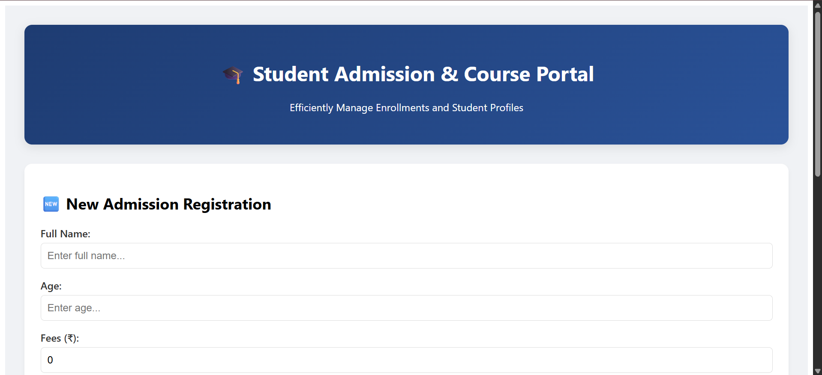

B. Admission Form Interaction
Demonstrates Two-Way Data Binding and Property Binding.
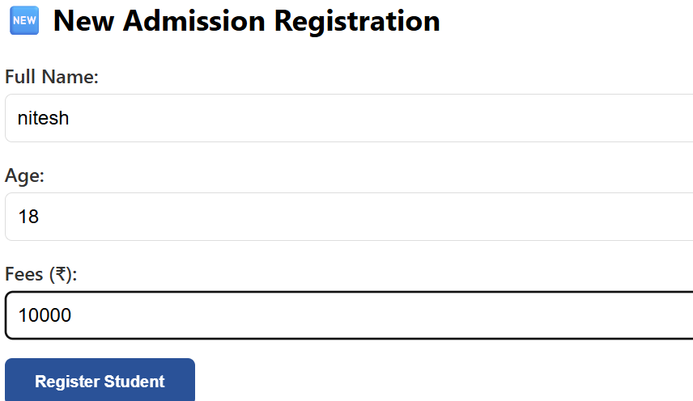

C. Enrollment List with Custom Pipe & Hover
Shows the dynamic table with Currency, Date, and Kebab-Case pipes active.
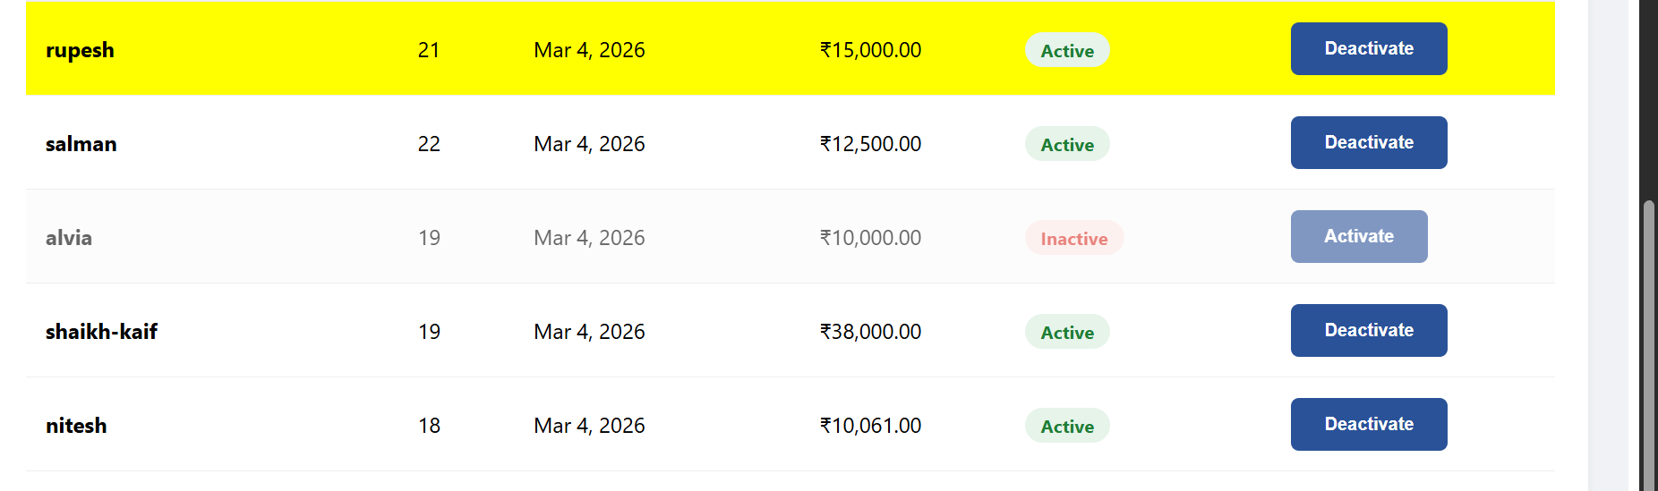

4. Important Commands Used
1. Create Project: ng new student-management-app
2. Create Component: ng generate component student
3. Create Directive: ng generate directive highlight
4. Create Pipe: ng generate pipe kebab-case
5. Run Server: ng serve

5. Conclusion
The Student Admission Portal successfully integrates various Angular features into a professional user interface. It proves how technical concepts like pipes and directives can solve real-world data presentation challenges.

